**Background**

The study of food consumption persists vastly amongst anthropologists, biologists, nutritionists, and various allied scientists. Anthropologists continue to conduct ethnographic studies on why, how, where and what humans eat. However, empirical ethnographic data does not allow for a computable database that can be used by varying individuals. The existing semi-structured data from anthropological research provides the necessary basis for creating the uc_eating ontology. The purpose of the uc_eating ontology is to create a standardized unambiguous characterization system for modeling human food habits and eating processes. The uc_eating ontology allows for the integration of aggregated data classified into eating behavior pattern phenotypes. Using data from various sources such as ethnographic data combined into a computable database permits for amassed food habits categorized across ethnic, age, socioeconomic and a variety of other groups/factors. The modeling of human eating practices stems from the very roots of history, critical in understanding intrinsic and extrinsic motivations behind food consumption. Such behaviors found in ethnographies such Food Between the Country and the City examines the relationship of food and the cities at which they belong to (Domingos et al.). Data collected from existing ethnographies allows for the integration and a basis for further understanding food choices and habits amongst populations. Utilizing sources such as sentiment analysis permits for the examination of existing ethnographies providing useable data collected into the eating ontology. More specifically, sentiment analyses may be tagged across food and how individuals feel surrounding their food. Sentiment analysis most commonly utilized as a means for capturing attitudes towards a particular topic remain useful, however, do not have quantifiable structured data. The absence of structured data makes it difficult to clearly and concisely extract data. Dissecting the ancestral behaviors of individuals is a key factor in further constructing an ontology that is accurate and qualitatively useful for various individuals. Natural language processing provides the necessary tools to conduct sentiment analysis on existing ontologies. The volume of food related websites and applications are rapidly increasing. Data across different platforms such as Yelp, Facebook, Twitter and other technological websites and applications make it challenging to extract relevant information. Existing ontology-based systems use keyword-based search engines making it difficult for concise extraction of words and data. Ontologies reformulate full-text query present in many search engines extracting only the relevant data available. Thus, the creation of ontologies requires a combination of informatic experts as well as subject matter experts to build abridged foundation of knowledge. The use of existing material such as Health and Taste Attitudes Questionnaire, Motivations to Eat Scale, Dutch Eating Behavior Questionnaire and the Food Choice Questionnaire can subsequently consolidated with the abilities of informaticians in building the eating ontology. It is vital in building the uc_eating ontology to obtain a plethora of data to ensure the diverse variability and precision of eating habits and consumption behaviors that exist amongst the human population. Ontologies such as the Hontology characterizing hotel attitudes towards experience hotel outline the analogous data mining practices at which the uc_eating ontology builds around food. (Chaves, Freitas, & Vieira,) The hontolgoy acts as one of many existing database structures containing web data in the Semantic Web.

**Introduction**

1.1 billion adults worldwide are considered overweight and 312 million are medically diagnosed as obese. Obesity is a growing epidemic, and rapidly becoming the single largest global

public health challenge [3]. Food, often consumed primarily for nutrifying and energetic purposes, is also consumed for purposes of improved performance of an array of human activities. As an example, individuals consuming multiple small meals per day compared to infrequent large meals, generally have an increased energy intake concomitant with increased energy expenditure in sports or other physical activities [4]. Aside from the frequency and timing of food consumption, food is often consumed as part of sociocultural rituals. In fact, many socioeconomic and sociocultural factors relate to choice architecture and behavioral responses surrounding foods consumption. Influences throughout life affect individual food choices, with downstream consequences for health phenotypes [5]. Food consumption practices often facilitate sharing of culture and bringing together of people in a social setting. In the last decade, American adult participation in social media climbed from seven to sixty-five percent of the population [6]. Exposure to social and mass media is altering food habits and consumption patterns of media consumers [7]. Modern science clearly demonstrates relationships between human eating behaviors and disease progression [8][9][10], to date they have received very limited attention in the world of ontological research. In their cogent assessment of obesity-related ontology patterns, Sojic and team highlight the need for “an eating pattern ontology of personalized profiles across several obesity-related knowledge-domains structured into dedicated modules in order to support inference about health condition, physical features, behavioral habits associated with a person, and relevant changes over time” [11]. The uc_Eating ontology has taken care to incorporate the most salient elements of Sojic’s eating pattern model and supports classification of these domain-specific patterns. Features such as eating habits, social and psychological influences, as well as nutritional condition, were considered when building our model of eating behaviors. The identification of eating behaviors as well as temporal, geographic, and social contexts in which these behaviors occur, form the basis for the uc_Eating model. Within the National Center for Biomedical Ontology, classifications of eating behaviors exist within a limited range of specifications. For example, the Gene Ontology characterizes eating behavior as the “reduction of food intake in response to dietary excess” providing little regard to the actual processes that coincide with eating/drinking or otherwise consumption of foods [12]. Our goal is to create a further detailed, unambiguous characterization of those eating behaviors.

**Methods**

The uc_Eating ontology is located on Github as part of the IC-FOODS repository of ontologies dedicated to ontologies related to Food Systems, Food, Behavior, and Health. Open world assumptions of semantic web ontology languages (OWL) provide a means for capturing the diverse array of human food consumption behaviors [13]. As a basis for our knowledge model, the construction of the food habit knowledge model enables the quantification and characterization of individual eating patterns [14]. Ontologies provide infrastructure for annotating relationships between food consumption and eating behaviors, providing the encoding of the unambiguous uc_Eating knowledge model into tractable and computable vocabularies. In order to begin building the usable data for the uc_eating ontology the extraction of data from varying resources was employed. The utilization of food habit questionnaires provides an infrastructure for annotating the occurring behaviors. Table 1 shows a piece of the “Eating Motivation Survey” codifying motivations behind food consumption.

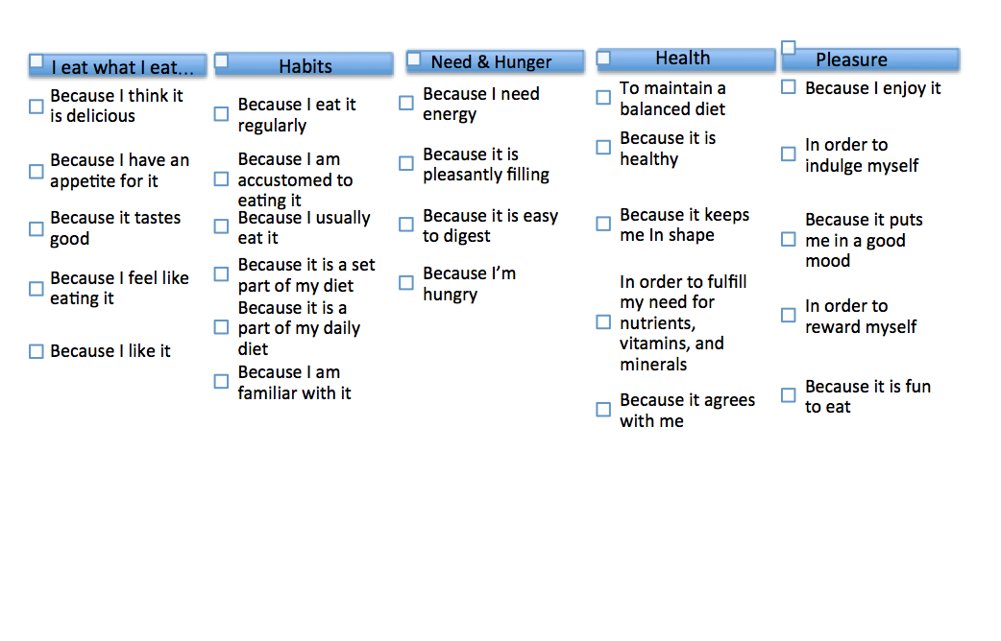

Table 1

The absence of structured data makes it difficult to clearly and concisely extract data

Methods : How you went about going to bring these things all together such as the questionnaires and what we did to extract the data within it

Results: the number of things we got from each we analyzed 10 quesstionares 3 papers for examples that was our corupis that we used to build the onoltogy

Look at key words in the honotlogy and see how it is mapped in the hontolgoy and try to import the hontolgoy into protege

[1] Domingos, N., Sobral, J. M., & West, H. G. (2014). Food between the country and the city: ethnographies of a changing global foodscape. London: Bloomsbury.

[2] Chaves, M., Freitas, L., & Vieira, R. (2012). Hontology: A multilingual ontology for the accommodation sector in the tourism industry.

[3] Hossain, P., Kawar, B., & Nahas, M. E. (2007). “Obesity and Diabetes in the Developing World — A Growing Challenge”. *New England Journal of Medicine N Engl J Med,* *356*(3), 213-215. doi:10.1056/nejmp068177.

[4]Hawley, J. A., & Burke, L. M. (1997). “Effect of meal frequency and timing on physical performance”. *British Journal of Nutrition Br J Nutr,* *77*(S1). doi:10.1079/bjn19970107I

[5] Nestle, M., Wing, R., Birch, L., DiSogra, L., Drewnowski, A., Middleton, S., SigmanGrant, M., Sobal, J., Winston, M. and Economos, C. (1998), “Behavioral and Social Influences on Food Choice”. Nutrition Reviews, 56: 50–64. doi: 10.1111/j.1753-4887.1998.tb01732.

[6] Perrin, A. (2015). “Social Media Usage: 2005-2015”. Retrieved May 15, 2016, from<http://www.pewinternet.org/2015/10/08/social-networking-usage-2005-2015/>

[7]Coary, S., & Poor, M. (2016). “How consumer-generated images shape important consumption outcomes in the food domain”. *Journal of Consumer Marketing,* *33*(1), 1-8. doi:10.1108/jcm-02-2015-1337

[8] Gu, Y., & Scarmeas, N. (2011). “Dietary Patterns in Alzheimer’s Disease and Cognitive Aging”. *Current Alzheimer Research*, *8*(5), 510–519.

[9] Who, J., & Consultation, F. E. (2003). “Diet, nutrition and the prevention of chronic diseases”. *World Health Organ Tech Rep Ser*, *916*(i-viii).

[10] McCullough, M. L., Feskanich, D., Stampfer, M. J., Giovannucci, E. L., Rimm, E. B., Hu, F. B., ... & Willett, W. C. (2002). “Diet quality and major chronic disease risk in men and women: moving toward improved dietary guidance”. *The American journal of clinical nutrition*, *76*(6), 1261-1271.

[11] Sojic, A., Terkaj, W., Contini, G., & Sacco, M. (2016). “Modularising ontology and designing inference patterns to personalise health condition assessment: The case of obesity”. *Journal of Biomedical Semantics J Biomed Semant,* *7*(1). doi:10.1186/s13326-016-0049-1

[12] Ashburner, M., Ball, C. A., Blake, J. A., Botstein, D., Butler, H., Cherry, J. M., … Sherlock, G. (2000). “Gene Ontology: tool for the unification of biology”. *Nature Genetics*, *25*(1), 25–29. http://doi.org/10.1038/75556

[13] Kim, J., Jang, M., Ha, Y., Sohn, J., & Lee, S. J. (2005). “MoA: OWL Ontology Merging and Alignment Tool for the Semantic Web”. Innovations in Applied Artificial Intelligence Lecture Notes in Computer Science, 722-731. http://doi.org/10.1007/11504894_100

[14] “Physical Activity Health and Fitness (PAHF) Ontology,” unpublished